# Quantum computers ready to leap out of the lab in 2017

Google, Microsoft and a host of labs and start-ups are racing to turn scientific curiosities into working machines.

* [Davide Castelvecchi](http://www.nature.com/news/quantum-computers-ready-to-leap-out-of-the-lab-in-2017-1.21239?WT.ec_id=NATURE-20170105&spMailingID=53127731&spUserID=MjA1NzUxMzcwMAS2&spJobID=1080713024&spReportId=MTA4MDcxMzAyNAS2#auth-1)

03 January 2017

## Article tools

[Rights & Permissions](https://s100.copyright.com/AppDispatchServlet?author=Davide+Castelvecchi&title=Quantum+computers+ready+to+leap+out+of+the+lab+in+2017&publisherName=NPG&contentID=10.1038%2F541009a&publicationDate=01%2F03%2F2017&publication=Nature+News)

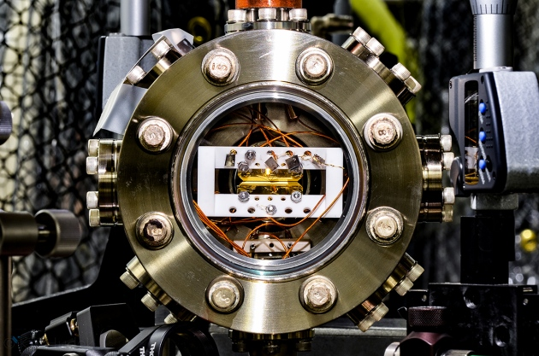

Kai Hudek, Univ. Maryland

A front runner in the pursuit of quantum computing uses single ions trapped in a vacuum.

Quantum computing has long seemed like one of those technologies that are 20 years away, and always will be. But 2017 could be the year that the field sheds its research-only image.

Computing giants Google and Microsoft recently hired a host of leading lights, and have set challenging goals for this year. Their ambition reflects a broader transition taking place at start-ups and academic research labs alike: to move from pure science towards engineering.

“People are really building things,” says Christopher Monroe, a physicist at the University of Maryland in College Park who co-founded the start-up IonQ in 2015. “I’ve never seen anything like that. It’s no longer just research.”

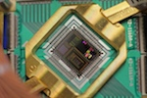

[**Google moves closer to a universal quantum computer**](http://www.nature.com/news/google-moves-closer-to-a-universal-quantum-computer-1.20032)

Google started working on a form of [quantum computing that harnesses superconductivity](http://www.nature.com/news/google-moves-closer-to-a-universal-quantum-computer-1.20032) in 2014. It hopes this year, or shortly after, to perform a computation that is beyond even the most powerful ‘classical’ supercomputers — an elusive milestone known as quantum supremacy. Its rival, Microsoft, is betting on an intriguing but unproven concept, [topological quantum computing](http://www.nature.com/news/inside-microsoft-s-quest-for-a-topological-quantum-computer-1.20774), and hopes to perform a first demonstration of the technology.

The quantum-computing start-up scene is also heating up. Monroe plans to begin hiring in earnest this year. Physicist Robert Schoelkopf at Yale University in New Haven, Connecticut, who co-founded the start-up Quantum Circuits, and former IBM applied physicist Chad Rigetti, who set up Rigetti in Berkeley, California, say they expect to reach crucial technical milestones soon.

Academic labs are at a similar point. “We have demonstrated all the components and all the functions we need,” says Schoelkopf, who continues to run a group racing to build a quantum computer at Yale. Although plenty of physics experiments still need to be done to get components to work together, the main challenges are now in engineering, he and other researchers say. The quantum computer with the most qubits so far — 20 — is being tested in an academic lab led by Rainer Blatt at the University of Innsbruck in Austria.

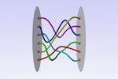

[**Inside Microsoft’s quest for a topological quantum computer**](http://www.nature.com/news/inside-microsoft-s-quest-for-a-topological-quantum-computer-1.20774)

Whereas classical computers encode information as bits that can be in one of two states, 0 or 1, [the ‘qubits’ that comprise quantum computers](http://www.nature.com/news/physics-quantum-computer-quest-1.16457) can be in ‘superpositions’ of both at once. This, together with qubits’ ability to share a quantum state called entanglement, should enable the computers to essentially perform many calculations at once. And the number of such calculations should, in principle, double for each additional qubit, leading to an exponential speed-up.

This rapidity should allow quantum computers to perform certain tasks, such as searching large databases or factoring large numbers, which would be unfeasible for slower, classical computers. The machines could also be transformational as a research tool, performing quantum simulations that would enable chemists to understand reactions in unprecedented detail, or physicists to design materials that superconduct at room temperature.

“I tell my students that 2017 is the year of braiding.”

There are many competing proposals for how to build qubits. But there are two front runners, confirmed in their ability to store information for increasingly long times — despite the vulnerability of quantum states to external disturbance — and to perform quantum-logic operations. One approach, which Schoelkopf helped to pioneer and which Google, IBM, Rigetti and Quantum Circuits have adopted, involves encoding quantum states as oscillating currents in superconducting loops. The other, pursued by IonQ and several major academic labs, is to encode qubits in single ions held by electric and magnetic fields in vacuum traps.

John Martinis, who worked at the University of California, Santa Barbara, until Google hired him and his research group in 2014, says that the maturity of superconducting tech­nologyprompted his team to set the bold goal of quantum supremacy.

The team plans to achieve this using a ‘chaotic’ quantum algorithm that produces what looks like a random output ([S. Boixo *et al.* Preprint at https://arxiv.org/abs/1608.00263; 2016](https://arxiv.org/abs/1608.00263)). If the algorithm is run on a quantum computer made of relatively few qubits, a classical machine can predict its output. But once the quantum machine gets close to about 50 qubits, even the largest classical supercomputers will fail to keep pace, the team predicts.

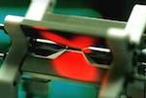

[**Quantum computer makes first high-energy physics simulation**](http://www.nature.com/news/quantum-computer-makes-first-high-energy-physics-simulation-1.20136)

The results of the calculation will not have any uses, but they will demonstrate that there are tasks at which quantum computers are unbeatable — an important psychological threshold that will attract the attention of potential customers, Martinis says. “We think it will be a seminal experiment.”

But Schoelkopf does not see quantum supremacy as “a very interesting or useful goal”, in part because it dodges the challenge of error correction: the ability of the system to recover its information following slight disturbances to the qubits, which becomes more difficult as the number of qubits increases. Instead, Quantum Circuits is focused on making fully error-corrected machines from the start. This requires building in more qubits, but the machines could also run more-sophisticated quantum algorithms.

Monroe hopes to reach quantum supremacy soon, but that is not IonQ’s main goal. The start-up aims to build machines that have 32 or even 64 qubits, and the ion-trap technology will enable their designs to be more flexible and scalable than superconducting circuits, he says.

Microsoft, meanwhile, is betting on the technology that has the most to prove. Topological quantum computing depends on excitations of matter that encode infor­mation by tangling around each other like braids. Information stored in these qubits would be much more resistant to outside disturbance than are other technologies and would, in particular, make error correction easier.



[**Sign up - it's free!**](http://www.nature.com/content/naturenews/index-TEX.html)

No one has yet managed to create the state of matter needed for such excitations, let alone a topological qubit. But Microsoft has hired four leaders in the field, including Leo Kouwenhoven of the University of Delft in the Netherlands, who has created what seems to be the right type of excitation. “I tell my students that 2017 is the year of braiding,” says Kouwenhoven, who will now build a Microsoft lab on the Delft campus.

Other researchers are more cautious. “I am not making any press releases about the future,” says Blatt. David Wineland, a physicist at the National Institute of Standards and Technology in Boulder, Colorado, who leads a lab working on ion traps, is also unwilling to make specific predictions. “I’m optimistic in the long term,” he says, “but what ‘long term’ means, I don’t know.”

Nature

541,

9–10

(05 January 2017)

doi:10.1038/541009a

# Inside Microsoft’s quest for a topological quantum computer

Alex Bocharov explains why the company is hoping to build qubits out of particles that some scientists think might not even exist.

* [Elizabeth Gibney](http://www.nature.com/news/inside-microsoft-s-quest-for-a-topological-quantum-computer-1.20774#auth-1)

21 October 2016

## Article tools

[Rights & Permissions](https://s100.copyright.com/AppDispatchServlet?author=Elizabeth+Gibney&title=Inside+Microsoft%E2%80%99s+quest+for+a+topological+quantum+computer&publisherName=NPG&contentID=10.1038%2Fnature.2016.20774&publicationDate=10%2F21%2F2016&publication=Nature+News)

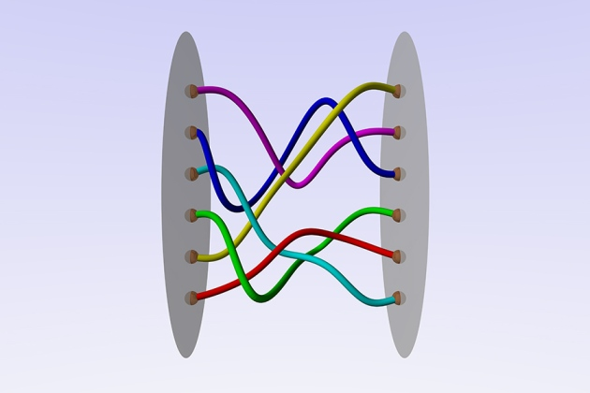

Ester Dalvit

The mathematical theory of braids could serve as the foundation for future topological quantum computers.

The race is on build a [‘universal’ quantum computer](http://www.nature.com/news/physics-quantum-computer-quest-1.16457). Such a device could be programmed to speedily solve problems that classical computers cannot crack, potentially revolutionizing fields from pharmaceuticals to cryptography. Many of the world's major technology firms are taking on the challenge, but Microsoft has opted for a more tortuous route than its rivals.

IBM, Google and a number of academic labs have chosen relatively [mature hardware](http://www.nature.com/news/google-moves-closer-to-a-universal-quantum-computer-1.20032), such as loops of superconducting wire, to make quantum bits (qubits). These are the building blocks of a quantum computer: they power its speedy calculations thanks to their ability to be in a mixture (or superposition) of ‘on’ and ‘off’ states at the same time.

Microsoft, however, is hoping to encode its qubits in a kind of quasiparticle: a particle-like object that emerges from the interactions inside matter. Some physicists are not even sure that the particular quasiparticles Microsoft are working with — called [non-abelian anyons](http://www.nature.com/news/2008/080416/full/452803a.html) — actually exist. But the firm hopes to exploit their topological properties, which make quantum states extremely robust to outside interference, to build what are called [topological quantum computers](http://www.nature.com/news/2008/080416/full/452803a.html). Early theoretical work on topological states of matter won [three physicists the Nobel Prize in Physics on 4 October](http://www.nature.com/news/physics-of-2d-exotic-matter-wins-nobel-1.20722).

The firm has been developing topological quantum computing for more than a decade and today has researchers  writing software for future machines, and working with academic laboratories to craft devices. Alex Bocharov, a mathematician and computer scientist who is part of Microsoft Research’s Quantum Architectures and Computation group in Redmond, Washington, spoke to *Nature* about the company’s work.



Alex Bocharov

Alex Bocharov works on topological quantum computing at Microsoft Research.

## How did Microsoft end up focusing on perhaps the most difficult quantum-computing hardware of all — topological qubits?

We’re people-centric, rather than problem-centric. And quantum-computing dignitaries, such as Alexei Kitaev, Daniel Gottesman and, most notably, Michael Freedman [the Fields Medal-winning director of Microsoft’s Station Q research lab], spearheaded the growth of our quantum-computing groups. So it was Freedman’s own trailblazing vision about how to do things that we followed.

## Both IBM and Google use superconducting loops as their qubits. What are the qubits you are trying to harness?

Our qubits are not even material things. But then again, the elementary particles that physicists run in their colliders are not really solid material objects. Here we have non-abelian anyons, which are even fuzzier than normal particles. They are quasiparticles. The most studied kinds of anyon emerge from chains of very cold electrons that are confined at the edge of a 2D surface. These anyons act like both an electron and its antimatter counterpart at the same time, and appear as dense peaks of conductance at each end of the chain. You can measure them with high-precision devices, but not see them under any microscope.

## Anyon-like particles were first predicted as stand-alone objects in 1937, and Kitaev suggested that quasiparticle versions could be used in quantum computers in 1997[1](http://www.nature.com/news/inside-microsoft-s-quest-for-a-topological-quantum-computer-1.20774#b1). But it was only [in 2012 that physicists first claimed to have spotted them](http://www.nature.com/news/a-solid-case-for-majorana-fermions-1.10174). Are you even certain that they exist?

We are pretty sure that the simplest species do exist. These were observed, we think, in 2012 by Leo Kouwenhoven at the Delft University of Technology in the Netherlands[2](http://www.nature.com/news/inside-microsoft-s-quest-for-a-topological-quantum-computer-1.20774" \l "b2" \o "Mourik, V. et al. Science 336, 1003–1007 (2012).). I wouldn’t say there is 100% consensus on that, but Kouwenhoven’s observation [has been reproduced in various other labs](http://www.nature.com/news/new-particle-is-both-matter-and-antimatter-1.16074)[3](http://www.nature.com/news/inside-microsoft-s-quest-for-a-topological-quantum-computer-1.20774#b3). It doesn’t really matter what exactly these excitations are, as long as they are measurable, and they can be used to perform calculations. Now it has come to a point where labs are putting together some very sophisticated equipment to produce those excitations in quantities and to try to start doing calculations.

## Developing anyons seems very difficult. What are the advantages of using anyons rather than other kinds of qubit?

# Related stories

* [Physics of 2D exotic matter wins Nobel](http://www.nature.com/doifinder/10.1038/nature.2016.20722)
* [Google moves closer to a universal quantum computer](http://www.nature.com/doifinder/10.1038/nature.2016.20032)
* [Physics: Quantum computer quest](http://www.nature.com/doifinder/10.1038/516024a)

[More related stories](http://www.nature.com/news/inside-microsoft-s-quest-for-a-topological-quantum-computer-1.20774#related-links)

In most quantum systems, information is encoded in the properties of particles, and the slightest interaction with their surroundings will destroy their quantum state. This means they operate with a precision of maybe 99.9%, or what we call three nines. To do real problems, we need precision at the level of ten nines, so you need to create a massive array of qubits that allows you to correct for the errors. Topological quantum computing has the promise of reaching up to six or seven nines, which means we wouldn't need to have this extensive and expensive error correction.

## What about topological quantum computing makes it so robust?

Noise from the environment and other parts of the computer is inevitable, and that might cause the intensity and location of the quasiparticle to fluctuate. But that’s OK, because we do not encode information into the quasiparticle itself, but in the order in which we swap positions of the anyons. [We call that braiding](http://www.nature.com/scientificamerican/journal/v294/n4/full/scientificamerican0406-56.html), because if you draw out a sequence of swaps between neighbouring pairs of anyons in space and time, the lines that they trace look braided. The information is encoded in a ‘topological’ property — that is, a collective property of the system that only changes with macroscopic movements, not small fluctuations.

## Microsoft has been working on topological quantum computing for more than a decade, for most of which the necessary qubits were hypothetical. Why are you playing such a long game?

It’s a game worth playing, because the upside is enormous and there is practically no downside. Microsoft is a very affluent company; it sits on something like US$100 billion in cash. So what else one would you invest in? Bill Gates is also investing in other things — to eradicate malaria and HIV — that might require quantum computing at some point. Genomics, for example, so far has been done on classical computers and there is a possibility that some huge progress could be made with something like 100–200 qubits on a quantum computer.

## How many people does Microsoft have working on quantum computing, and how much are you spending?

A rough number I would say is 35–40 people, but I don’t think I’m at liberty to speak about the amount of money, even in terms of rough estimates.

## Your team has been working on developing software for this kind of quantum computer. What have you been up to?

So far, we’ve had an amazing ride in terms of creating more-efficient algorithms — reducing the number of qubit interactions, known as gates, that you need to run certain computations that are impossible on classical computers. In the early 2000s, for example, people thought it would take about 24 billion years to calculate on a quantum computer the energy levels of ferredoxin, which plants use in photosynthesis. Now, through a combination of theory, practice, engineering and simulation, the most optimistic estimates suggest that it may take around an hour. We are continuing to work on these problems, and gradually switching towards more applied work, looking towards quantum chemistry, quantum genomics and things that might be done on a small-to-medium-sized quantum computer.

## Isn’t this jumping the gun, given that a working quantum computer that could handle such questions is still perhaps a decade away?

In the past, the question was always whether something was a problem where a quantum computer would be hypothetically better than a classical computer. Now we want to figure out, not just is it doable, but how doable is it? We need to move a lot of earth to figure that out, but it’s worth it, because we believe this is going to be a whole industry in itself.