4 | Methylene number of active carbon

The aim of the laboratory practice is evaluation of coloring agents removal from waste water efficiency.

INTRODUCTION
Methylene number is a parameter of active carbon (AC) which gives opportunity to indicate de-coloring properties of AC (sorption properties in solutions). Other analytical methods of sorption properties indication are exemplary:
Iodine number;
Phenol number;
Molasses number;
Detergent number;
pH number;
and it use depends on range of AC application.

“Methylene blue (CI 52015) is a heterocyclic aromatic chemical compound with the molecular formula C₁₆H₁₈N₃SCl. It has many uses in a range of different fields, such as biology and chemistry. At room temperature it appears as a solid, odorless, dark green powder, that yields a blue solution when dissolved in water. The hydrated form has 3 molecules of water per molecule of methylene blue.” [1]
Caution:
“Methylene blue should not be confused with methyl blue, another histology stain, new methylene blue, nor with the methyl violets often used as pH indicators.” [1]

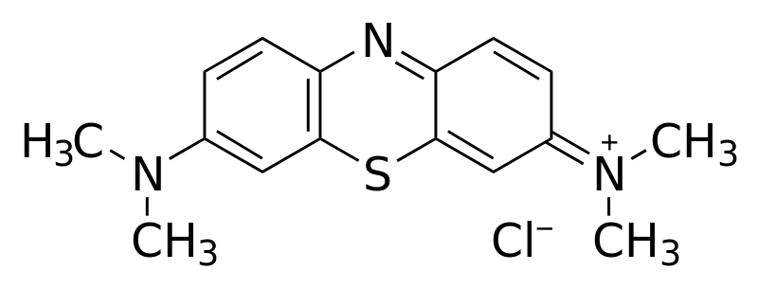
Fig. 1 Structural chemical formula of methylene blue [1]

Molar mass 319.85 g/mol (pure substance)
Molar mass 373,9 g/mol (hydrated by 3 molecules of water – typical commercial form)

Reference
[1] http://en.wikipedia.org/wiki/Methylene_blue (2012-11-03)

4 | Methylene number of active carbon

APPARATUSES AND APPLIANCES
Spectrophotometer, cuvettes (absorption cells), laboratory shaker
GLASS AND CHEMICALS
Methylene Blue, active carbon, laboratory bulbs, laboratory flasks with stoppers, measuring pipettes

Measuring schedule
- Prepare base solution of the methylene dye by dissolving of 25 mg of the Methylene Blue in 500 cm³ of distilled water.
- Prepare the set of standard dye solutions:
  - to 7 measuring flask of 10 cm³ volume batch 0.05; 0.1; 0.2; 0.4; 0.5; 0.8; 1.0 cm³ of base solution and fill the flask to the mark using distilled water
  - calculate concetration of obtained solutions in mg/dm³
  - measure the absorbance A of standard solutions using wavelength λ=660 nm in the cuvette of thickness of absorbing layer 1 cm
- Measure of cleaning effectiveness of dye solution by the active carbon
  - to the flask with with stopper of 100 ml volume sample 0.1 g of active carbon with accuracy of 4 fractional numbers (after the dot). Do two repeats (together 3 samples) for the same carbon
  - Add the 50 cm³ of base dye solution. Shake the vessel on the laboratory shaker by the 60 minutes.
  - After shaking separate the solution using paper filter
  - Measure the absorbance A of the solution using wavelength λ=660 nm in the cuvette of thickness of absorbing layer 1 cm
Data procesing
- Data on the absorbance of the standard dye solutions express on the chart absorbance versus concentration of the dye. Draw the line of tendency. In such a way the calibration curve appears.
- Using the calibration curve find the concentration of the solution obtained after adsorption on active carbon.
- Calculate the adsorption in g of dye per g of AC [g/g], this value is called methylene number.
Questions (short, several statement answer):
- Which property (or properties) plays role in sorption properties (especially adsorption)?
- Why silver coating is used for purification of drinking water?

