Methylene number of active carbon

The aim of the laboratory practice is evaluation of coloring agents removal from waste water efficiency.

INTRODUCTION
Methylene number is a parameter of active carbon (AC) which gives opportunity to indicate de-coloring properties of AC (sorption properties in solutions). Other analytical methods of sorption properties indication are exemplary:
Iodine number;
Phenol number;
Molasses number;
Detergent number;
pH number;
and it use depends on range of AC application.

“Methylene blue (CI 52015) is a heterocyclic aromatic chemical compound with the molecular formula C₁₆H₁₈N₃SCl. It has many uses in a range of different fields, such as biology and chemistry. At room temperature it appears as a solid, odorless, dark green powder, that yields a blue solution when dissolved in water. The hydrated form has 3 molecules of water per molecule of methylene blue.” [1]
Caution:
“Methylene blue should not be confused with methyl blue, another histology stain, new methylene blue, nor with the methyl violets often used as pH indicators.” [1]

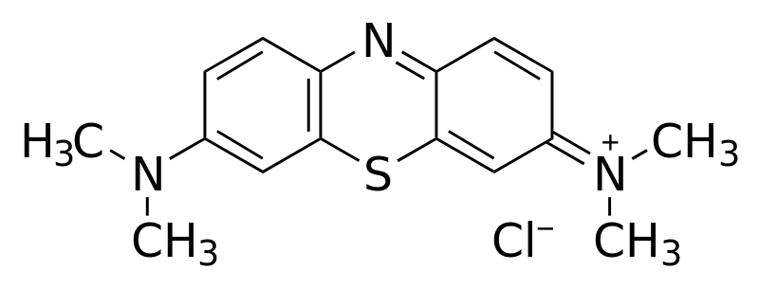
Fig. 1 Structural chemical formula of methylene blue [1]

Molar mass 319.85 g/mol (pure substance)
Molar mass 373,9 g/mol (hydrated by 3 molecules of water – typical commercial form)

APPARATUSES AND APPLIANCES
Spectrophotometer, cuvettes (absorption cells), laboratory shaker
GLASS AND CHEMICALS
Methylene Blue, active carbon, laboratory bulbs, laboratory flasks with stoppers, measuring pipettes

Measuring schedule
- Prepare base solution of the methylene dye by dissolving of 25 mg of the Methylene Blue in 500 cm³ of distilled water.
- Prepare the set of standard dye solutions:
  - to 7 measuring flask of 10 cm³ volume batch 0.05; 0.1; 0.2; 0.4; 0.5; 0.8; 1.0 cm³ of base solution and fill the flask to the mark using distilled water
  - calculate concetration of obtained solutions in mg/dm³
  - measure the absorbance A of standard solutions using wavelength λ=660 nm in the cuvette of thickness of absorbing layer 1 cm
- Measure of cleaning effectiveness of dye solution by the active carbon
  - to the flask with with stopper of 100 ml volume sample 0.1 g of active carbon with accuracy of 4 fractional numbers (after the dot). Do two repeats (together 3 samples) for the same carbon
  - Add the 50 cm³ of base dye solution. Shake the vessel on the laboratory shaker by the 60 minutes.
  - After shaking separate the solution using paper filter
  - Measure the absorbance A of the solution using wavelength λ=660 nm in the cuvette of thickness of absorbing layer 1 cm
Data procesing
- Data on the absorbance of the standard dye solutions express on the chart absorbance versus concentration of the dye. Draw the line of tendency. In such a way the calibration curve appears.
- Using the calibration curve find the concentration of the solution obtained after adsorption on active carbon.
- Calculate the adsorption in g of dye per g of AC [g/g], this value is called methylene number.
Questions (short, several statement answer):
- Which property (or properties) plays role in sorption properties (especially adsorption)?
- Why silver coating is used for purification of drinking water?
Reference
[1] http://en.wikipedia.org/wiki/Methylene_blue (2012-11-03)

