Superkondensatory

A supercapacitor is a high-capacity electrochemical capacitor with capacitance values greater than 1,000 farads at 1.2 volt that bridge the gap between electrolytic capacitors and rechargeable batteries. They typically store 10 to 100 times more energy per unit volume or mass than electrolytic capacitors, can accept and deliver charge much faster than batteries, and tolerate many more charge and discharge cycles than rechargeable batteries. They are however 10 times larger than conventional batteries for a given charge.
Supercapacitors are used in applications requiring many rapid charge/discharge cycles rather than long term compact energy storage: within cars, buses, trains, cranes and elevators, where they are used for regenerative braking, short-term energy storage or burst-mode power delivery. Smaller units are used as memory backup for static random-access memory (SRAM). (https://en.wikipedia.org/wiki/Supercapacitor)

Nalezy najpierw wprowadzic w temat superkondensatorow, np. poprzez przedstawienie podstaw z artykulu Superkondensatory – magazyny energii elektrycznej, lub a nastepnie starac sie przedstawic to co jest omowione w artykuliku w Nature (lub w pelnym artykule w Advance Materials).

Literatura:
1. A. Lisowska-Oleksiak et. al., SUPERKONDENSATORY JAKO MATERIAŁY DO MAGAZYNOWANIA ENERGII
2. Zenan Yu, Energy Storing Electrical Cables: Integrating Energy Storage and Electrical Conduction, Adv. Mater. 2014, 26, 4279–4285 (i zachęta do tego artykulu z Nature: Energy storage wrapped up)

Supercapacitor nano-architecture: Designing a plant-powered future
Physics World, 16 May 2018
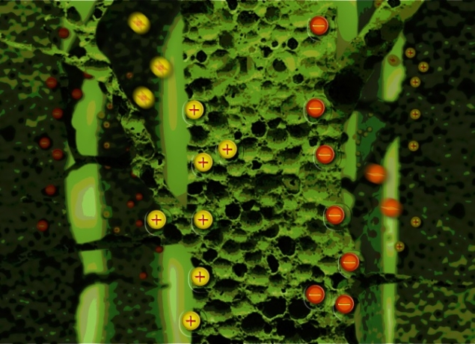A schematic representation of how a hierarchical porous structure promotes supercapacitance, in electrode materials derived from plants. This provides a low-cost, abundant and environmentally friendly alternative to current materials. Image featured as a front cover image in Sustainable Energy Fuels (Credit: Dina Ibrahim Abouelamaiem and Dina Mohammadieh)
“The most crucial result of this work is the correlation between form and function in supercapacitor materials” states first author Dina Ibrahim Abouelamaiem. She elaborates that “our research is driven by the need for a greener future and improved energy systems”, which is why their Sustainable Energy Fuels paper focuses on understanding how the 3D structure affects the supercapacitor properties of biocarbon-based materials derived from plant cellulose. These materials could provide an environmentally friendly alternative to precious metals and toxic chemicals currently used in top-performing supercapacitors.

Powering the future
Supercapacitors are devices full of potential, quite often literally, as they are charged to exhibit high power densities and long lifetimes. Due to these properties, supercapacitors are able to “bridge the gap” in device performance between batteries and fuel cells. Understanding the nanostructure in depth and over multiple length scales is paramount in order to optimize performance and design better devices. By combining an extensive set of complementary techniques, Ibrahim and her colleagues have shed light on the complex synergy between structure and performance and show that a hierarchical porous network is what electrode materials need to have in order to function best.
Advertisement
In their study, biocarbon electrodes activated using potassium hydroxide act as a model system, and the findings are also tested against commercial materials in order to demonstrate wider applicability. Characterization techniques such as SEM (scanning electron microscopy), BET (Brunauer-Emmett-Teller theory for nitrogen adsorption), XPS (X-ray photoelectron spectroscopy), and X-ray CT (X-ray computed tomography) represent a portion of those utilized to form a complete picture of the materials. This long list of techniques (and associated large number of acronyms) covers a wide range of length scales, which means the researchers were able to anlayse nano-, micro-, meso- and macro-pores altogether.
According to Ibrahim, it was the large suite of techniques available from the Electrochemical Innovation Lab (EIL) located in UCL’s Department of Chemical Engineering that allowed the researchers to “plug the gap” in understanding structure-function relationships in supercapacitor devices.
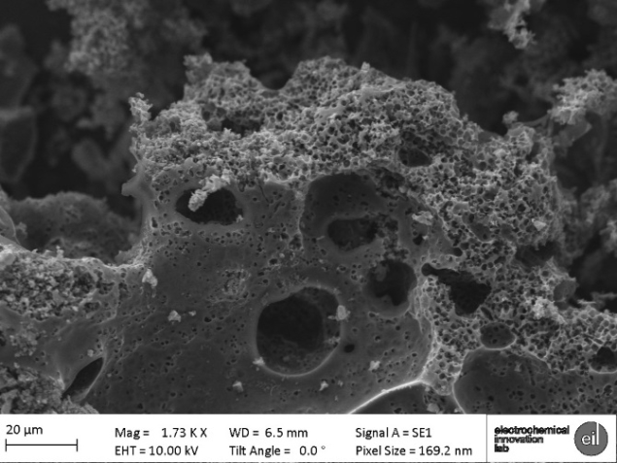Research shows that a mixture of pore sizes is integral to designing optimized biocarbon materials for use in supercapactors. (Photo credit: Dina Ibrahim Abouelamaeim)

Within the pores of a supercapacitor
Results show that an increase in performance of materials is seen with a mixture of pore sizes nestled within one another, forming a hierarchical structure. Measurements reveal direct correlation between high specific surface area and low cell resistance, which leads to a high specific capacitance. The team tested the performance of the supercapacitors using varied electrochemical set ups and over extended operating cycles to demonstrate the lifetime performance and stability of the materials. These findings set the scene for more efficient and higher performing energy storage devices in the near future.
Full details of the research are reported in Issue 4 of Sustainable Energy Fuels, DOI: https://doi.org/10.1039/C7SE00519A
Oscar Williams is a PhD student contributor to nanotechwbe.org, currently studying catalysis exhibited in gold nanoparticles, primarily explored through scanning tunnelling microscopy alongside other surface science techniques. He studies at the Advanced Characterization of Materials CDT, which is a collaborative PhD between UCL and Imperial universities

IN DEPTH
May 19, 2016

Supercapacitors empower sustainable energy storage
In 1957 petrol became the world’s most used fuel, and nuclear energy began to gain ground as a credible energy source – power has been a dirty pleasure ever since. Yet the same year also saw Howard Becker at General Electric invent the first supercapacitor, a comparatively clean and sustainable form of stored energy.
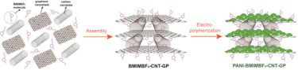
Hybrid structures meet wide-ranging demands
Supercapacitor technology didn’t see much further attention beyond the first patent for several years. However, more recently as the world gawps at the prospect of catastrophic anthropological climate change, the technology has attracted a great deal of attention from researchers keen to exploit its potential to supply a practical, clean energy solution that might help avert environmental disaster. Far from a purely academic field of research, the global supercapacitors market reached $2 billion in 2015. Nanotechnology collects some of the latest developments in this pacey field, where advances in functional nanostructures are making headway towards the potential widespread use of supercapacitors as sustainable energy storage devices.

Getting the right materials
Progress in material science has unearthed a number of options that offer great advantages for supercapacitor nanostructures, including those based on electrostatic double-layer capacitance, electrochemical pseudocapacitance and hybrids. Poly(3,4-ethylenedioxythiophene) – PEDOT – is a conducting polymer that offers supercapacitor devices the advantages of low-cost and flexibility while delivering good electrical conductivity and pseudocapacitance, so long as issues with its stability can be overcome.
Another hot nanotechnology material with particular relevance to supercapacitor research is graphene. Surface area tends to be directly related to an increased capacitance or energy density, and in graphene all atoms are surface atoms. In this collection researchers at the Beijing Institute of Technology in China and the Helmholtz-Zentrum Dresden-Rossendorf in Germany review some of the advantages posed by what they describe as a “fascinating material” – graphene fibres. The benefits they list include a “unique and tunable nanostructure, high electrical conductivity, excellent mechanical flexibility, light weight, and ease of functionalization.”
The environmental motivation for supercapacitor research has also encouraged an impressive resourcefulness for sustainable synthesis of supercapacitor materials. Reports along these lines in the collection demonstrate promising supercapacitor properties from freeze drying nitrogen-doped porous carbon cryogel, as well as the production of activated carbon – the most common material for electrochemical double layer capacitors – from bark and coffee grounds.

Getting the structure right
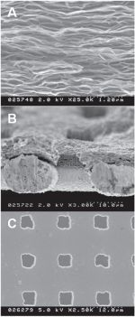
Etching holes in graphene
As the name suggests, supercapacitors generally have the lead on dielectric or electrolytic capacitors in terms of capacitance. However, they tend to be slow operating, which has prompted research into the use of nanostructuring, with for example, arrays of pores, to decrease ionic impedance. Unfortunately, the advantages these large pores bring can be offset by the excess of the other materials that are then required to support large pore arrays. By exploring the behaviour of graphene with small naturally occurring pores, Matthew H Ervin from the US Army Research Laboratory in Maryland demonstrates an approach for speeding up supercapacitors, and potentially other types of devices such as batteries and sensors as well.
Francesco Iacopi and colleagues at Griffith University and Queensland University of Technology in Australia, and the University of South Florida, Plasma-Therm LLC and Air Force Research Laboratory in the US, demonstrate another approach for producing naturally porous graphene in “the first attempt to produce graphene with a high surface area from silicon carbide thin films for energy storage at the wafer-level”. The researchers suggest that the method may open numerous opportunities for on-chip integrated energy storage applications.
Other nanostructures besides pores and arrays have also been exploited. When Junhong Chen, Shun Mao and their colleagues looked to improve the supercapacitor properties of transition metal sulphides to compete with oxide counterparts, they used a nanowire structure to maximize the surface area. Their aim was to exploit the high conductivity and stability of metallic CoS₂. By growing the nanowires directly on to their substrates, the team of researchers at the University of Wisconsin-Madison in the US and Fujian Institute of Research on the Structure of Matter in China could ensure low contact resistance, which also helped achieve good cyclability – just 0–2.5% loss of capacity after 4250 cycles. Compared with single-phased material, these hybrid materials with a hierarchical nanostructure can provide shorter ion transport pathways, offer synergetic effects from multiple active components and have easily accessible electroactive sites for the electrolyte ions.
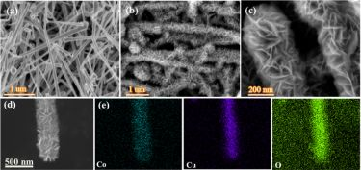
Hierarchical Cu₂O/CuO/Co₃O₄ core-shell nanowires

Mixing it up
Where finding one material that meets all the required characteristics can be elusive, combining the best properties from a range of materials is a popular solution. “The facile design of hierarchical architecture and control over the multi-composition offers a new strategy for the fabrication of electrodes for high-performance supercapacitors,” suggest Shauchun Tang, XiangKang Meng and colleagues at Nanjing University in their report on MnO₂ supercapacitors enhanced with electrochemically active Fe₃O₄ in the interior and electrically conductive SnO₂ nanoparticles in the surface layer.
Some other examples of successful hierarchical supercapacitor structure designs include Cu₂O/CuO/Co₃O₄ core-shell nanowires by Li Li Zhang and Yu Xin Zhang and colleagues in China and Singapore and the polyaniline–graphene–carbon nanotube structures by Yimin Sung and Hongwei Duan and collaborators at Wuhan Institute of Technology in China and Nanyang Technological University in Singapore.
The intrinsic reversibility of superficial redox couples, as well as good electronic conductivity, ultrahigh pseudocapacitance, and extremely long cycle life, has attracted a lot of interest in nanocrystalline hydrous ruthenium dioxide. However, as Chu-Chuang Hu and colleagues at National Tsing Hua University in Taiwan point out, “such excellent performances, unfortunately, cannot be maintained for relatively thick, nanocrystalline RuO₂•xH₂O and amorphous RuO2•xH₂O films, especially in high-power applications.” The solution? They incorporate RuO2•xH2O onto a reduced graphene oxide/carbon nanotube conducting backbone to facilitate electron transport with impressive results: a total specific capacitance of 973 F g⁻¹ at 25 mV s⁻¹; good capacitance retention of 60.5%; and a scan rate varying from 5 to 500 mV s⁻¹.
From the exploitation of new nanomaterials and nanostructure design for optimized performance to smart and sustainable synthesis, the papers in the collection demonstrate how progress in supercapacitor research may play an important role in meeting global energy demands with environmentally friendly technology. Guest edited by Liming Dai, at Case Western Reserve University and Yury Gogotsi at Drexel University in the US, and Husnu Emrah Unalan at Middle East Technical University in Turkey, the collection gives real meaning to the old adage “knowledge is power”.
- This article first appeared on Nanotechnology

About the author
Anna Demming is editor of nanotechweb.org

Further reading
PEDOT-based composites provide electrode materials for supercapacitors (Feb 2016)
Supercapacitors empower sustainable energy storage (May 2016)
Etched holes increase speed of graphene electrodes (Jun 2015)
Structural supercapacitors take a load on (May 2014)

